**Application Development:**



Prodesign Technologies has over 5 years of Experience in Robust, cutting-Edge software Development, and has been a Good Competitor in providing high quality IT professionals to help our clients meet the most challenging deadlines comfortably. We also offer our clients completely managed end-to-end Application Development and ongoing maintenance solutions at both Enterprise and Entrepreneurial levels.

**Prodesign helps companies overcome the following challenges:**

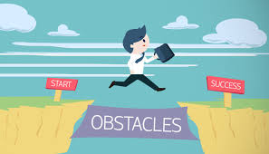

1 .Reduce Development cost

2 . Transform your Legacy system to a new Technology Platform

3 .Customized integration with ERP system

4 .Software Development Life Cycle management of key business processes to reduce development cost.

**Prodesign Application Development and MAINTENANCE provides the following solutions:**

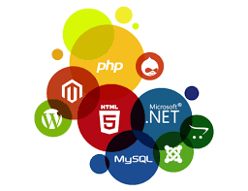

Application Development and Maintenance: Effectively develop and manage Application portfolio through Customizable solutions to provide Custom Applications by Maximizing Return on Investment.

Application Support: We Provide the Application support for the Client with less Knowledge in Technologies like java , Hadoop and Devops ..etc

Application Integration: Integrate complex applications into one unified and optimized computing platform with minimal risk.

**How Prodesign Technologies can make difference In IT Industry :**



Comprehensive Application Development MAINTENANCE Services: We deliver a full range of change-the-business, run-the-business, and cross-functional IT application services that are scalable, robust, secure, and maintainable.

Domain Knowledge: Clients benefit from our deep industry domain knowledge and technical expertise to deliver transformational results. Prodesign Application services are Industrialized to reduce cost and increase predictability and agility.

Investment in Solutions: Our sustainable investment in innovative solutions ensures that our clients benefit from the latest accelerators, methodologies, and engagement models tailored to meet their changing needs.

A Focus on Results: We provide clients with Application Development Management services and solutions that deliver real value. We offer a range of services from the development of initial application requirements to the global management of the entire application portfolio. Throughout the project lifecycle, our focus is on fulfilling the Company Desired Requirements and providing measurable results.